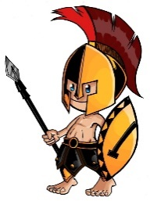
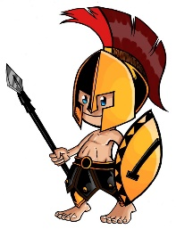
Oak Park Elementary School
4331 Henry Street
Shreveport, Louisiana 71109

Mrs. Julia Smith O’Neal, Principal

School Uniform Policy for the 2017-2018 SY

PreK through 5th Grade Students:
- Tops: Short or long-sleeve hunter green or light yellow uniform shirts
- Bottoms: Khaki or navy blue pants or shorts, skorts, jumpers or capris.
  - Pants must be uniform-style pants. No cargo pants, overalls, etc.
  - Shorts are not allowed during the winter season.
- Belts must be worn.
- The only hoodies allowed will be the Oak Park hoodie or a hunter green hoodie.
- Only Oak Park sweatshirts can be worn.
- If leggings are worn, they must be black, navy blue or white.

